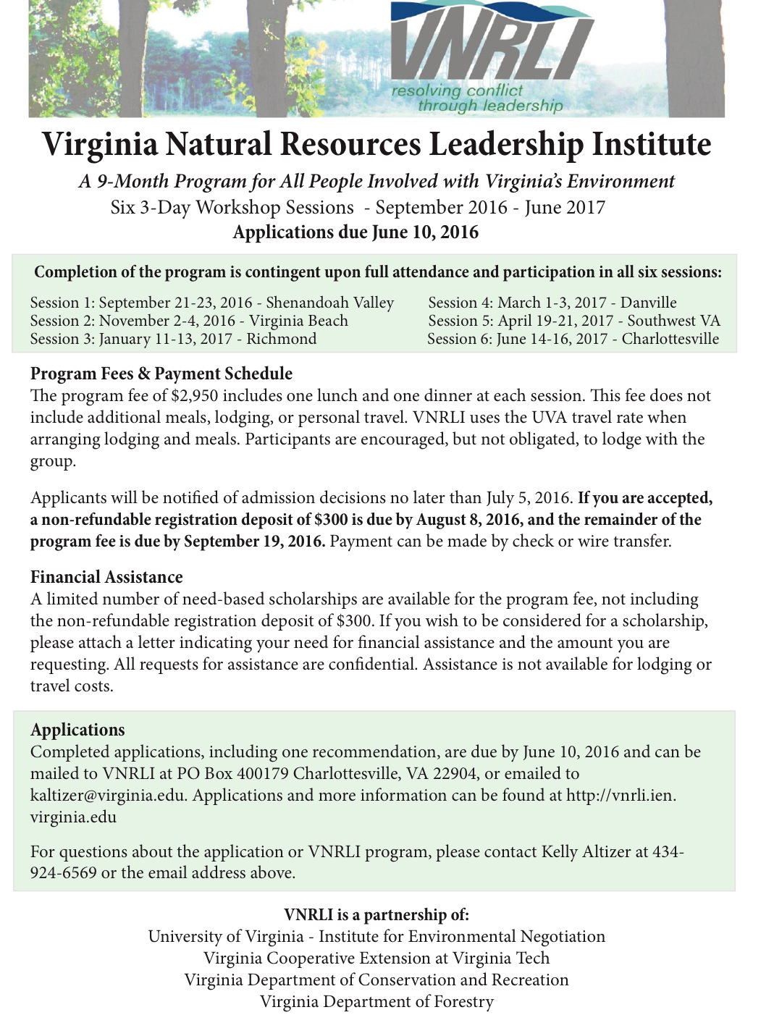
Virginia Natural Resources Leadership Institute
Applications due by June 10, 2016

Full Name:

Preferred name for name tag, if different than above: _________________________________________________________________

City/State:______________________________________________

Phone ( ) ( )
Work Cell
Work email: ☐ preferred

Personal email: ____________________________________________________ ☐ preferred

We request both work and personal email addresses so that we can still reach you in the event that you change jobs, but will only use your preferred address for VNRLI communication.

Optional:
Age Gender Race

Education

Name & Location Dates Attended Degree

High School

College

Other

Current Employment

Employer/Business Name

Employer Address

Position Title Employment Date

Present Responsibilities

Additional Employment History

Employer and Location Position/Title Dates of Employment

Organizations and Activities

What is the nature of your involvement (personal and/or professional) with natural resources or the environment?

What do you feel is your greatest responsibility, skill, or achievement to date in your professional or personal life?

What are your future career and/or community service goals?

Please list, in order of importance to you, no more than three professional, civic, or state/national organizations in which you are or have been a member within the past 3 years.

Organization Length of Office Held Term of Office
Membership

VNRLI Goals

What do you hope to achieve from your experience in the Virginia Natural Resources Leadership Institute?

An important component of VNRLI is the application of skills learned in the sessions. Describe any ideas you have about specific applications that you foresee, including in any industries, business, groups, organizations, or communities where you hope to apply these skills.

Participation Agreement

Who will pay your registration? Employer Yourself Other (specify)

Food, lodging & travel expenses? Employer Yourself Other (specify)

If requesting a scholarship, please indicate the amount of assistance you are requesting (requests are limited to a maximum of $2650) and attach a letter explaining your request: _________________________

I understand the goals and objectives of the Virginia Natural Resources Leadership Institute and, if selected to participate, I will pay a non-refundable registration deposit of $300 by August 8, 2016 and the remainder of the program fee by September 19, 2016. I understand that participation requires attendance at all VNRLI sessions and I am willing to devote the time to this program as described in this application.

Applicant's Signature

I understand the time commitment required for my employee to participate in the Virginia Natural Resources Leadership Institute and approve of his/her absence if selected to participate.

Employer's Signature (where applicable)

Virginia Natural Resources Leadership Institute
Recommendation due by no later than June 10, 2016
Only one recommendation required

Name of Applicant
Full name

For the Applicant

The Family Education Rights and Privacy Act of 1974 and its amendments guarantee students access to educational records concerning them. Applicants are permitted to waive their rights of access to recommendations. The following signed statement indicates the wish of the applicant regarding this recommendation.

I waive my right to inspect the contents of the following recommendation.

I do not waive my right to inspect the contents of the following recommendation.

Signed Date

To the Recommender

The person whose name appears above is applying for admission to the Virginia Natural Resources Leadership Institute. The VNRLI seeks applicants who are, or who have the potential to become leaders within their organizations or communities. Your evaluation will be included as a part of the information on which we will base our admission decision. Your candid evaluation of the applicant is appreciated.

1. How long and in what capacity have you known the applicant?

2. Please use the space below and additional sheets if necessary to make statements on the applicant's qualifications for admission to a leadership program. Include his/her potential for becoming a leader within his/her organization, profession, or community, as well as an assessment of the applicant's major strengths and leadership skills.

3. Using the table below, please compare the applicant with others you have known.

 | Outstanding  (Top 10%) | Very Good  (Top 20%) | Good  (Top Third) | Average  (Middle Third) | Below Average  (Bottom Third) | No Opportunity  To Observe
Leadership

Ability to work well with others
Self-confidence

Motivation and drive

Personal Integrity

Oral communication
Skills
Written communication
Skills
Creativity and
Imagination

4. I ____________________________ this applicant for admission to the Virginia Natural Resources Leadership Institute.

Strongly recommend Recommend with some reservation*

Recommend Do not recommend

*My reservations are:

Signature Date

Name

Title Organization

Business Address

City State Zip Code Phone

This completed recommendation form must be received no later than Friday, June 10, 2016. Submit by mail or email: VNRLI, P.O. Box 400179, Charlottesville, VA 22904, Email: kaltizer@virginia.edu

